Create a copy of this page on your own

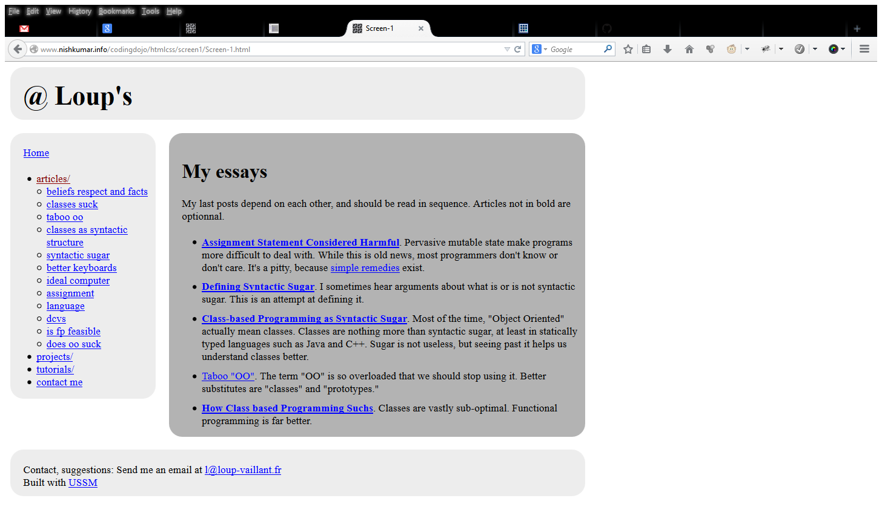

Solution: <http://www.nishkumar.info/codingdojo/htmlcss/screen1/Screen-1.html> Solve it yourself!